RHE Overview
Statutory Requirement: Changing Adolescent Body
1. Key facts about puberty and the changing adolescent body, particularly from age 9 through to age 11, including physical and emotional changes. (Year R to 6)
2. About menstrual wellbeing including the key facts about the menstrual cycle.
Year Group | Lesson Titles | Key Learning Points  Children will be able to: | Vocabulary | Images / Activities
R | Life stages – plants, animals, humans  Life stages  Where do babies come from?  Getting bigger  Me and My Body – Girls and Boys | - To understand that animals and humans change in appearance over time.  - Use relevant vocabulary such as egg, seed, baby, grow, change, old, young (and the names for young animals).  - Make observations and ask questions about living things.  - Retell a story and respond to questions about it.  - Use the language and describe the different life stages of: baby, child, teenager, adult, older age.  - Talk about their own experience of growing up.  - Explain that a baby is made by a woman and a man, and grows inside a mother’s tummy.  - Understand that every family is different.  - Talk about similarities and differences between themselves and others.  - Talk about how they have changed as they have grown.  - Explain the differences between babies, children, and adults.  - Understand that we are all unique.  - Name parts of the body (including reproductive parts) using the correct vocabulary.  - Explain which parts of their body are kept private and safe and why.  - Tell or ask an appropriate adult for help if they feel unsafe. | Lifecycles, reproduction  Womb, egg, sperm,  Penis, Vagina(using correct vocabulary from a safeguarding perspective)  Private, | Youtube Videos:  https://www.youtube.com/watch?v=w77zPAtVTuI&ab_channel=GPhase  https://www.youtube.com/watch?v=7NhA9SHunKs&ab_channel=LifeForBeginners  https://www.youtube.com/watch?v=G3VMl-EY2DM&ab_channel=TheDodo  Story – ‘Once there were giants’  Book – ‘There’s a house inside my Mummy’  Matching baby animals to adult animals  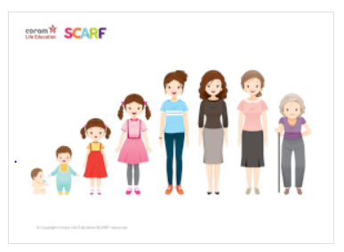  NSPCC: Pantosaurus song  https://www.youtube.com/watch?v=-lL07JOGU5o&ab_channel=NSPCC
1 | Good and bad touches  Taking care of a baby  Then and now  Keeping private parts, private | - Understand and learn the PANTS rules;  - Name and know which parts should be private;  - Explain the difference between appropriate and inappropriate touch;  - Understand that they have the right to say “no” to unwanted touch;  - Start thinking about who they trust and who they can ask for help.  - Understand some of the tasks required to look after a baby;  - Explain how to meet the basic needs of a baby, for example, eye contact, cuddling, washing, changing, feeding.  - Identify things they could do as a baby, a toddler and can do now;  - Identify the people who help/helped them at those different stages.  Children will be able to:  - Identify parts of the body that are private;  - Describe ways in which private parts can be kept private;  - Identify people they can talk to about their private parts. | Penis, vagina, touch  Breast feeding  Bottom, penis, testicles, vulva, private parts | NSPCC: Underwear Rule resource  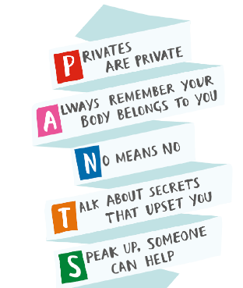  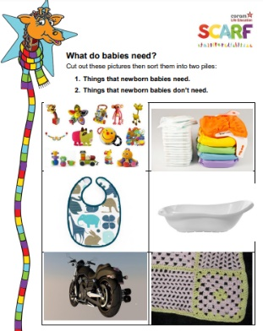  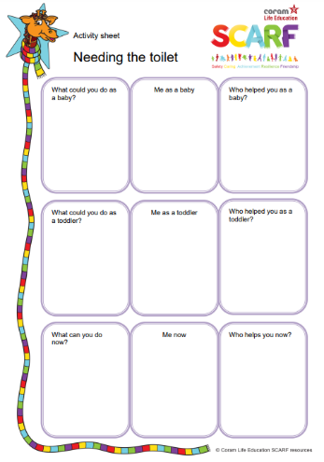
2 | Haven’t you grown!  My body, your body | - Identify different stages of growth (e.g. baby, toddler, child, teenager, adult);  - Understand and describe some of the things that people are capable of at these different stages.  - Identify which parts of the human body are private;  - Explain that a person's genitals help them to make babies when they are grown up;  - Understand that humans mostly have the same body parts but that they can look different from person to person. | Independent, growing, changing, adult permission, making choices to keep safe  Cultural clothing eg Hijab, body parts, boys body, girls body, penis, vulva, testicles, nipples, private parts, genitals, head, ears, belly button (navel) difference between boys and girls, private, knees, toes, fingers, urine, sperm, baby, eggs, ovaries, womb, embryo, genitals, breast, breastfeed | 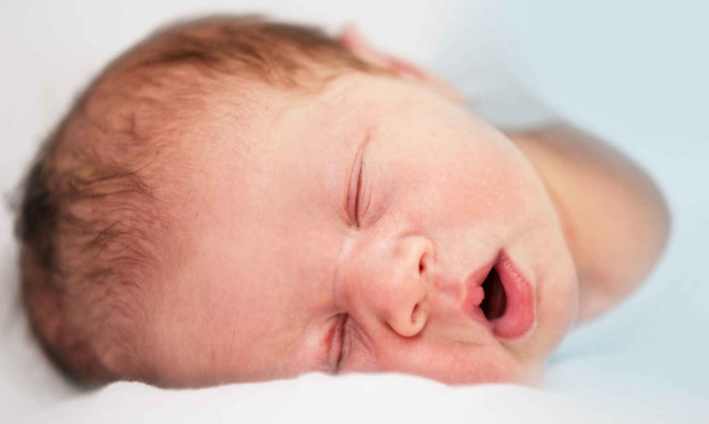  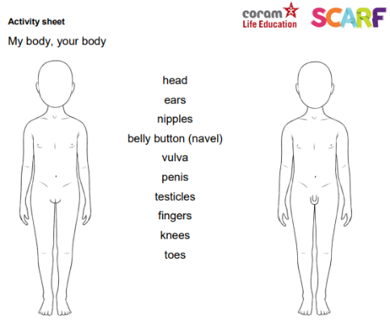
3 | My changing body  Alcohol & Cigarettes  Body space | - Recognise that babies come from the joining of an egg and sperm;  - Explain what happens when an egg doesn’t meet a sperm;  - Understand that for girls, periods are a normal part of puberty.  Children will be able to:  - Identify some key risks from and effects of cigarettes and alcohol;  - Know that most people choose not to smoke cigarettes; (Social Norms message)  - Define the word 'drug' and understand that nicotine and alcohol are both drugs.  Children will be able to:  - Understand what is meant by the term body space (or personal space);  - Identify when it is appropriate or inappropriate to allow someone into their body space;  - Rehearse strategies for when someone is inappropriately in their body space. | Menstruation, periods, egg, sperm, breasts, genitals, ovaries, fallopian tube, vagina, bleed, pads, tampons, wet dreams, vaginal opening  Alcohol, cigarettes, drugs, vaping, cancer  Physical contact, touch, kiss, private parts, | 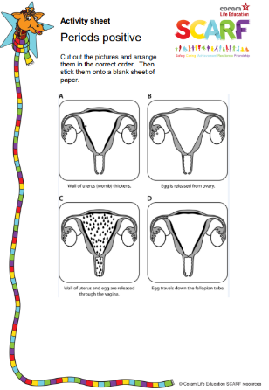  https://kidshealth.org/en/teens/menstruation.html (Video)  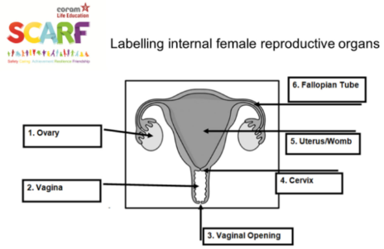  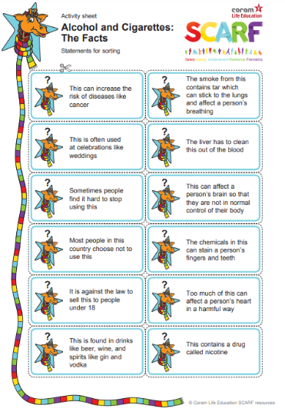
4 | Preparing for changes at puberty  All change!  My feelings are all over the place | - Know the key facts of the menstrual cycle;  - Understand that periods are a normal part of puberty for girls;  - Identify some of the ways to cope better with periods.  - Identify parts of the body that males and females have in common and those that are different;  - Know the correct terminology for their genitalia;  - Understand and explain why puberty happens.  - Name some positive and negative feelings;  - Understand how the onset of puberty can have emotional as well as physical impact  - Suggest reasons why young people sometimes fall out with their parents;  - Take part in a role play practising how to compromise. | Video clip from kidshealth website acne, anus, balls, biological sex, bra, breasts, cervix, chromosomes, clitoris, deodorant, discharge, ejaculation, erection, emotions, fallopian tubes, foreskin, friends, gender, gender identity, gender expression, hair, hygiene, hormones, inner lips, intersex, IVF, labia, masturbation, menstruation cups, menstruation pads, oestrogen, progestogen, orgasm, outer lips, ovary, ova, ovum, period pants, penis, pubic hair, prostate gland, semen, seminal fluid, sex, sexual awakening, sexual intercourse, sexual orientation, sexual reproduction, scrotum, smegma, sperm, sperm duct, tampon, testicles, urethra, urinary opening, uterus, wet dreams, womb. | 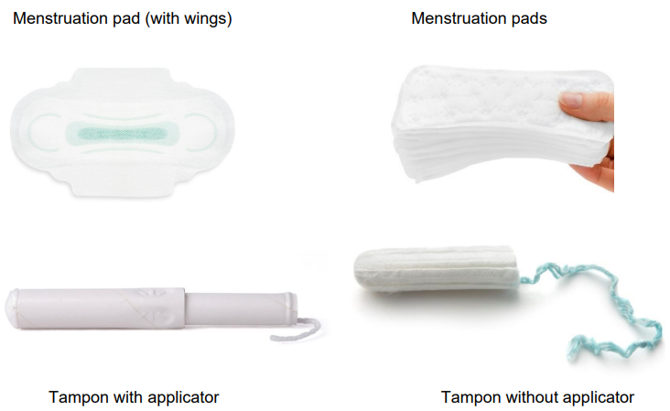  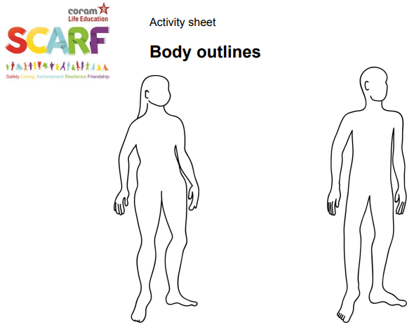
5 | Growing up and changing bodies  Help, I’m a teenager – get me out of here!  Changing bodies and feelings  Vaping: Healthy or unhealthy? | - Identify some products that they may need during puberty and why;  - Know what menstruation is and why it happens.  - Recognise how our body feels when we’re relaxed;  - List some of the ways our body feels when it is nervous or sad;  - Describe and/or demonstrate how to be resilient in order to find someone who will listen to you.  - Know the correct words for the external sexual organs;  - Discuss some of the myths associated with puberty.  Children will be able to:  - Describe some of the health risks caused by vaping;  - Understand that there are potential health risks of vaping that are not yet fully known;  - Use critical thinking skills when reading information/media;  - Understand that companies selling vaping products do so to make money;  - Describe some of the possible outcomes of taking a risk. | Body parts, FGM, puberty, periods, menstruation, hormones, pads, tampons, breasts, vagina, discharge, penis, semen, testes, erections, wet dreams, ovaries, eggs, fallopian tubes, bleed, cuts, genitalia, vulva  Puberty, gay,  Puberty, reproduction, periods, menstruation, LGBT, masturbation, erection, semen, wet dreams, pubic hair, outer lips, labia, vaginal opening, vulva, clitoris, urinary opening, anus, inner lips, foreskin, penis, testicles, scrotum, breasts, stretch marks  Vaping, drugs, cigarettes, nicotine, smoking, tobacco | 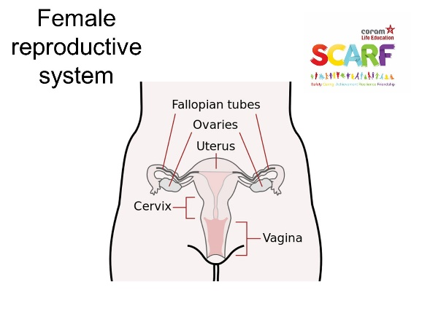  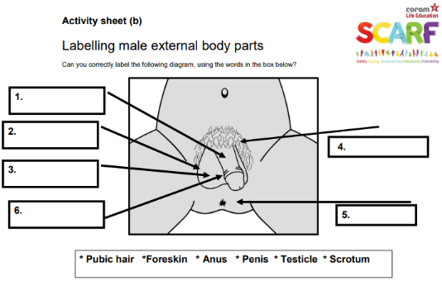  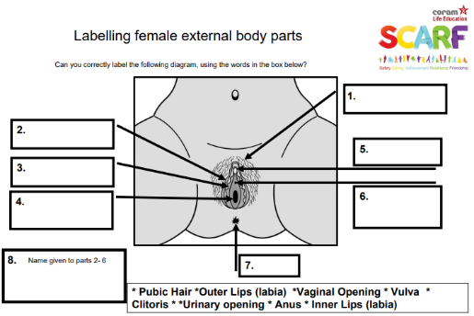
6 | What’s the risk (2)  Making babies  (NON-STATUTORY LESSON)  SEX EDUCATION LESSON – Parents must be informed  I look great  Is this normal?  Dan’s day (Optional) | - Recognise what risk is;  - Explain how a risk can be reduced;  - Understand risks related to growing up and explain the need to be aware of these;  - Assess a risk to help keep themselves safe.  - Identify the changes that happen through puberty to allow sexual reproduction to occur;  - Know a variety of ways in which the sperm can fertilise the egg to create a baby;  - Know the legal age of consent and what it means.  - Understand that fame can be short-lived;  - Recognise that photos can be changed to match society's view of perfect;  - Identify qualities that people have, as well as their looks.  - Define the word 'puberty' giving examples of some of the physical and emotional changes associated with it;  - Suggest strategies that would help someone who felt challenged by the changes in puberty;  - Understand what FGM is and that it is an illegal practice in this country;  - Know where someone could get support if they were concerned about their own or another person's safety.  - Describe the consequences of reacting to others in a positive or negative way;  - Suggest ways that people can respond more positively to others. | Very high risk for me  Very low risk for me  It depends if…  Manage and reduce the risk  Perceived risk  Eggs released, periods start, breast develop, wet dream, erection, sperm  Sexual intercourse, sex, conception, internal reproductive organs, hug, cuddle, kiss, orgasm, hard penis, vagina, wet, lubricated, caesarean, cut stomach, womb, queer, gay, ovary, vagina, cervix, fallopian tube, uterus, vaginal opening, adoption, surrogacy, IVF, contraception, condom, consent, consensual, illegal  Social media, well-groomed, fashionable, perfect make up, celebrities, enhance the final image, manipulated image, Dove Selfie Project (watch video)  Puberty, periods, menstruate, menstruation, blood, blood flow, spots, agony aunt, female genitalia, female genital mutilation, vulva, vagina, acne, anus, balls, biological sex, bra, breasts, cervix, chromosomes, clitoris, deodorant, discharge, ejaculation, erection, emotions, fallopian tubes, foreskin, friends, gender, gender identity, gender expression, hair, hygiene, hormones, inner lips, intersex, IVF, labia, masturbation, menstruation cups, menstruation pads, oestrogen, progestogen, orgasm, outer lips, ovary, ova, ovum, period pants, penis, pubic hair, prostate gland, semen, seminal fluid, sex, sexual awakening, sexual intercourse, sexual orientation, sexual reproduction, scrotum, smegma, sperm, sperm duct, tampon, testicles, urethra, urinary opening, uterus, wet dreams, womb.  Man-up, stressed, angry, yelling, being unkind, boasting, | 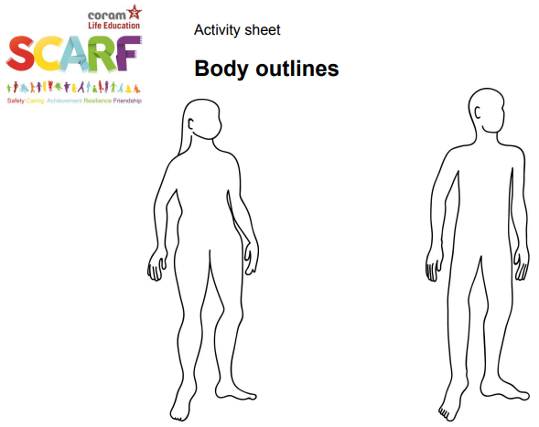  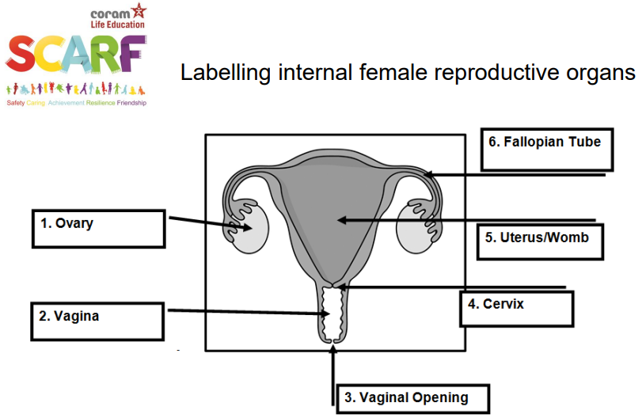  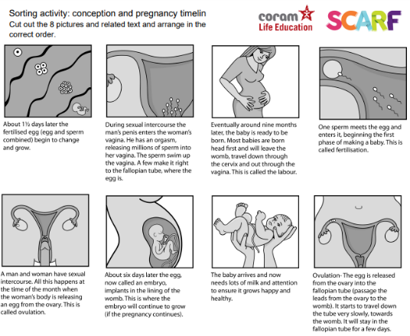

BEING SAFE
- That each person's body belongs to them, and the differences between appropriate and inappropriate or unsafe physical, and other, contact.

